LAB Logbook

Lab 1

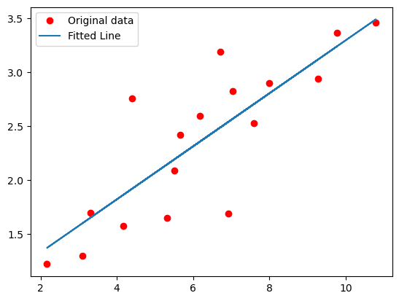

Lab 2

Lab 3

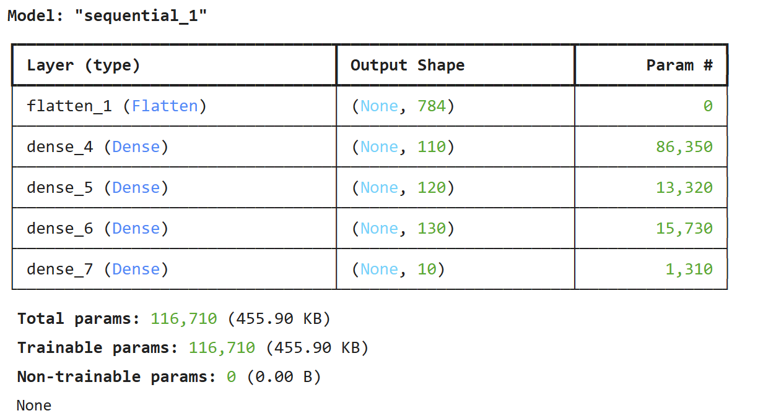

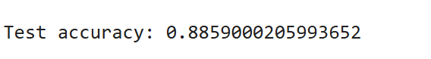

Lab 4

Lab 5

Based on the analysis optimal number of epochs for training the model is 4,5.

Lab 6

Lab 7

Lab 8

Lab 9

Lab 10

Lab 11

Lab 12